Statement of Purpose
“Discover potential, enjoy success, prepare for life.”

Mission Statement

Our purpose is to provide outstanding care and education to the UK’s most vulnerable and difficult to place children, within education or in a supportive and understanding environment of residential care.

We offer each and every child and young person courtesy and respect, and work in conjunction with local authorities to deliver a range of care, education and other specialist services which offer best value whilst ensuring the best possible outcomes for each child.

As a group, we benefit from a wealth of experience allowing young people the opportunity to thrive and develop by realising their potential whilst being happy and feeling valued.
The Grange Therapeutic School is in the parish of Knossington, which is in the district of Melton, Leicestershire and close to the border of Rutland. Rutland is the UK’s smallest county and has its largest manmade lake. Rutland has a rich historical heritage, the roman Saxon settlement, a 12th century castle in Oakham, ancient churches and stone built villages, visits to the county museum in Oakham can be a place to explore the history of this small county. Knossington Village and beside the school has a local church for Christians to worship, however the home is located near to Leicester city centre which is diverse and has a variety of places to worship for all different religions.
At the Grange Therapeutic School, we are an inclusive learning and therapeutic community that is forward thinking, innovative and committed to ensuring that all pupils are happy, enthusiastic and purposeful learners. We believe that every pupil must be provided with opportunities to develop socially, emotionally and academically to achieve the highest possible standards, the same as we would want for our own children. On leaving the school we want our pupils to have the social skills, education and confidence to thrive in the adult world.

The Grange Therapeutic School welcomes all referrals from placing authorities looking for residential placements for children and young people. However, be aware that for all “Looked After Children”, there must be permanently named carers and a permanent home base for the pupil, available at any time throughout the year. This placement should be stable and secure. The school cannot be the main residence for any child.

There are two residential homes located within the grounds of the Grange Therapeutic School. They are named The Manor and The Spinney. They are both located within the grounds of The Grange Therapeutic School on Somerby Road and offer a 38-week residential placement.

The Manor is a 7-bedroom property that can accommodate a residential care place for children and young people.

The Spinney is also a 7-bedroom property that can accommodate a residential care place for children and young people.

Both homes are situated close to Rutland water where activities take place and have woodland behind both homes that are owned by the school where the children and young people can enjoy the outdoors and nature the setting offers. We are located around 4 miles away from Oakham town centre, 2 miles from Somerby village, 1 mile from Cold Overton village, 8.6 miles from Melton Mowbray town centre and Leicester city centre is 17 miles away. Oakham Train Station is located 3.8 miles away.

In summary the residential homes can accommodate:
- 14 children and young people across both homes
- Any Gender
- Children with social, emotional and/or behavioural difficulties (SEMH).
- Children with learning disabilities and children with a diagnosis of Autism.
- Care and accommodation providing a safe space to develop independent skills, whilst building emotional resilience and receiving care tailored to individual needs

Objectives/Aims

The Grange Therapeutic School and Care provides a holistic, safe, stimulating and supporting family environment where any child/young person cared for can live, learn and develop.

The homes provide a high standard of care, educational support and accommodation for 14 young people. We work in partnership with relevant Social Care departments, and other agencies within a clear and comprehensive policy framework, in line with corporate and localised policies.

The Grange Therapeutic School and Care delivers care following theories of therapeutic parenting which provides young people with a nurturing environment where we are able to support their emotional development. Our primary therapeutic model of care is PACE (Playfulness, Acceptance, Curiosity and Empathy), this is a DDP informed model of care.

The DDP Network describe PACE as:

“PACE is a way of thinking, feeling, communicating and behaving that aims to make the child feel safe. It is based upon how parents connect with their very young infants. As with young toddlers, with safety the child can begin to explore.
With PACE, the troubled child can start to look at themselves and let others start to see them, or get closer emotionally. They can start to trust.”

Staff are trained in PACE to ensure they are equipped with the skills to work with young people in line with this model. At the Grange we believe that achieving ‘connection’ before ‘correction’ is essential to supporting young people. We respond to the emotional needs of young people so that their feelings are validated and they have a chance to express these in a safe and secure environment. Staff are non-judgemental in their approach with young people which supports young people to process historic trauma and shame, supporting a strong trusting connection to be formed.

Therapeutic models, including PACE and Zones of Regulation are embedded into various practices within the homes which not only ensures staff consistently work within the therapeutic model but also that young people become more aware of their own emotions.

We are a diverse, professional team who pride ourselves on working together that prides itself on creating a friendly, caring atmosphere with nurture at the centre of everything we do. We work together holistically to empower each other to ensure the young person feels valued and respected. Staff are recruited based on their knowledge and experience but also their personal values and characteristics, honesty, trustworthiness, compassion but most of all, caring for and wanting the best for our young person.

The Grange therapeutic School has high expectations and aspirations for any young person who resides with us. We emphasise the importance of education and celebrate achievements. We aim to provide the young person with the vital skills they need to go on to lead independent and fulfilled lives. Young people who have previously been placed with us have gone on to achieve independence and have gained access to further education to fulfil their true potential.

Wellbeing and Clinical Service

Outcomes First Groups (OFG) Wellbeing and Clinical model recognises that all the people we support are individual and our provision is tailored to meet their strengths and their needs from the start of their journey and throughout their time with us.

Who Supports the Home and Young People
Wellbeing and Clinical Service support is available for all of our young people, care and education teams, the support is provided by a team of clinicians which include the following professions: Psychology, Psychotherapy, Occupational Therapy and Speech and Language Therapy. Within these professions, there will be specialist disciplines e.g. Art, Psychodynamic and/or Drama Psychotherapy, and Educational, Forensic, Counselling and/or Clinical Psychology.
Each homes designated clinical support will reflect the strengths and needs of the young people that live within the homes, however additional support can also be accessed from other specialists within the wider clinical teams across the group where required.
This enables us to be responsive to any newly identified, time limited or changing needs of an individual throughout their placement with us.

How The Home and Young People Are Supported
Our therapeutic offer is informed by the OFG Wellbeing Rainbow; this strategy places wellbeing at the core of everything we do. The rainbow represents a tiered approach to wellbeing support at a multi-professional level. Please see diagram and description below which represents the Wellbeing Rainbow: 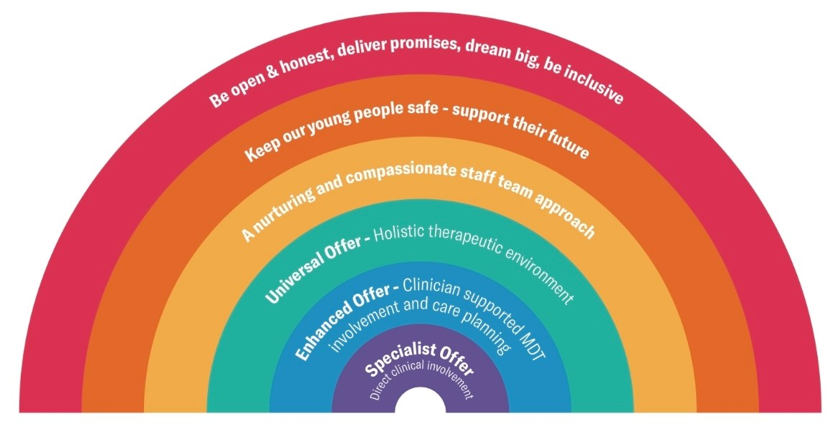
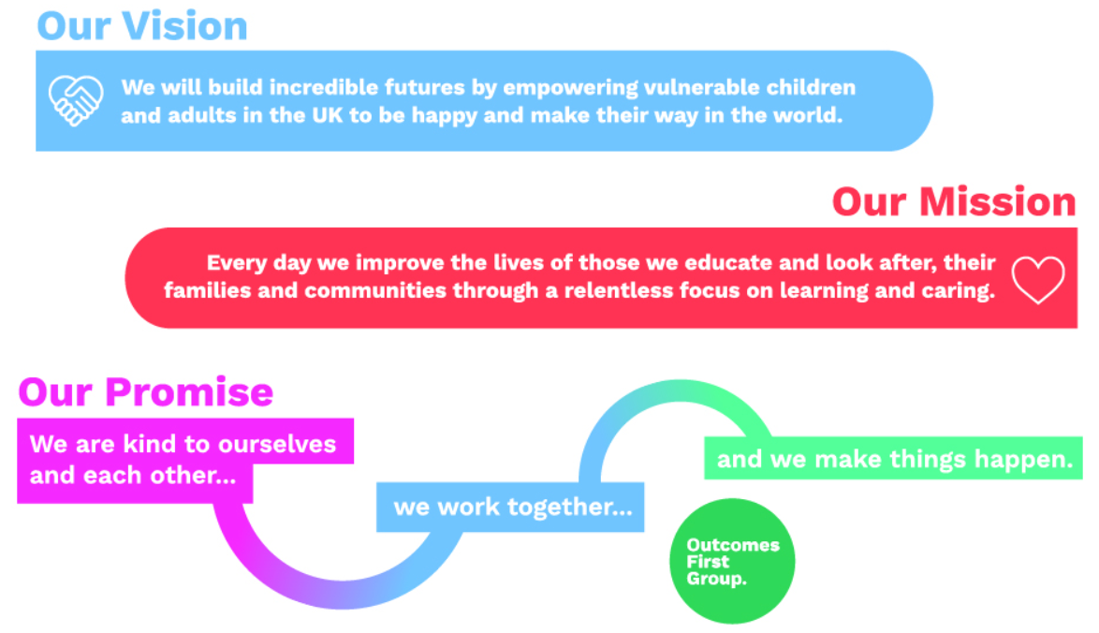

Education and Care work together to:
- Raise achievement through a commitment to high standards and expectations.
- Enable every child to succeed as an independent, enthusiastic and confident learner
- Provide active, co-operative and independent learning through dynamic high quality teaching
- Create an atmosphere where each child is valued as an individual, enabling them to develop a positive self-image, self-discipline and respect and tolerance for others
- Ensure equality of opportunity at all times, so that each child is given appropriate support and enrichment.
- Create an inclusive learning community which challenges and enables every learner to flourish, prosper and develop aspirations for a successful future
- Provide a welcoming, secure, stimulating and enriched learning environment.
- Provide an innovative, creative and integrated curriculum which inspires and motivates children to learn and which takes account of different learning styles and their future aspirations
- Work in partnership with parents, carers, children and the wider community
- Support pupils through a range of therapeutic interventions to meet their SEMH needs.
The success of each individual is founded on our core values of respect, dignity, trust and wellbeing; a commitment to realising the potential of each child and young person through a broad and enriching curriculum, growing independence and widening the opportunities for continued learning and work.

Opportunities for Cultural, Leisure, Recreational & Social Activities

There are a wide range of leisure, recreational, and social activities that are available for the child/young person to pursue whilst residing at Manor and the Spinney. The homes are deliberately located in close proximity to various facilities with excellent transport links to local towns and cities. Our staff team ensure that any child/young person is encouraged to participate in communal and group activities of their own choice.

We place a lot of value on high quality, high value activities for young people where they are able to enjoy positive experiences, these are based on their own interests but also new activities they may not have previously been able to access. We understand that unfortunately for many young people living at the home they may not have had many opportunities to enjoy a range of positive activities, this could be through a variety of reasons from financial constraints, neglect or due to family not being able to safely offer opportunities and as such may not have fully learned how to ‘have fun’. We ensure that every young person is fully supported to engage in positive activities both onsite and in the community, young people are fully involved in planning their own activities at a level suited to their needs with full support from staff. The provision of activities in the home fully compliments our model of care, with particular regards to Playfulness and also supports the forming of strong connections.

At the Manor and the Spinney, all staff recognise the importance of monitoring the participation in leisure, recreational, and social activities, whilst ensuring that adequate alternatives are offered to every child/young person, as and when required. Also, that a child/young person is entitled to time when she or he is doing nothing in particular but is engaged in a range of in-house activities or learning to self-regulate their time.

There are a wide range of leisure, recreational, and social activities available, including access to and use of fitness gyms, youth clubs, tennis, badminton, cinemas, football, cookery, arts & crafts, bowling, climbing centres, horse-riding, ice skating to name a few.

Each child/young person is involved in completing a weekly Personal Planner that sets out the structure of the week ahead. This ensures that both the child and staff are able to form a picture of the week ahead ensuring balance and variety. This system also serves to review and monitor activities undertaken in the home. The young person can also voice their choices in their young person’s meetings which are held monthly. Children and young people in the home take part in regular key working sessions with their key members of staff. Furthermore, unplanned key working sessions take place on a regular basis when young people participate in discussions or share their feelings and emotions.

At the Manor and the Spinney, we promote a range of individual and group activities, these are essential for supporting the building of positive relationships with both peers and staff and also supporting young people to build a positive self-image. Young people across both homes will have opportunities to participate in social group activities, enjoy social events together whilst also being supported to enjoy more individual interests and hobbies.

Consulting children/young people about their care

Any child/young person living at The Grange Therapeutic School is encouraged and supported in self-expression. They are encouraged and helped to recognise their rights and responsibilities. In support of this, any young people are encouraged to participate in regular monthly house meetings. The house meetings are used to celebrate achievements of the young people, discuss any topical issues, develop social interaction and to have a bit of fun. We aim to make the monthly meetings a bit of a celebration and may choose to have a special tea, sing along or play some group games as part of the meeting.

We believe it is important that young people are supported to express their feelings wherever possible, to support young people with this staff use a range of methods for capturing this information. These include questionnaires, online surveys and verbal feedback. This ensures that there is always a medium in which young people can communicate their feelings effectively. Also, children/young people are supported and encouraged to take part in the reviews of their Care and Placement Plans.

At the Manor and the Spinney we have a Share It Box, this is somewhere that young people are encouraged to share their experiences, thoughts and feelings. Where possible staff will support the young people to help the young people understand how they are feeling and how they can be best supported

The young people receive ongoing support and encouragement and regular planned one to one key working sessions allow them to feed into the home’s decision-making processes further. Key work is planned in advance to meet the individual needs of young people living in the home. Staff are encouraged and expected to elicit the views of our children and to ensure these are considered in the day to day running of our homes.

Young People will be made aware that they have access to their social worker and IRO.

Promoting positive behaviour and relationships

The Grange Therapeutic School recognises that many young people who may be accommodated at the home have a negative experience of consequences and their ramifications. OFG therefore believes in positive reinforcement and rewarding positive behaviour, this acts to reinforce positive outcomes for young people and also to minimise shame, which is a negative emotion. Staff seek to promote positive choices and behaviour through carefully designed, personalised reward schemes and plans and by working with young people to get a deeper understanding of the emotions driving their behaviours.
The Behaviour policy OFG adopts is a non-punitive and no sanctions-based approach. Positive reinforcement combined with natural and logical consequences support a positive and whole school culture.
All children require boundaries and consequences that are fair, predictable and understandable. Children are encouraged to be a part of devising these.
Natural Consequences occur without the intervention of an adult. For example, a young person might throw a favoured object when they are feeling angry which might then break and therefore cannot be used. Shame is also considered a natural consequence, and young people will require support with this.
Logical consequences are adult-led and are linked to the event, and when a natural consequence may not occur or may be a safety hazard. For example, if a young person removing their seatbelt during a car journey – a logical consequence to ensure safety may be to avoid car journeys whilst a plan to ensure seatbelts are worn is in place.
Natural and Logical Consequences will be communicated to the young person in an empathic and collaborative way, never in a shaming way.
Care have adopted the same approach as the school in that we do not use punitive sanctions, for example detention, removal of privileges, continuing with a consequence at home after the incident at school. These can promote a sense of shame, are often not linked to the behaviour and therefore do not encourage our pupils to learn what to do instead. The consequence must always be linked to the behaviour to provide a learning opportunity.
Repairing relationships (a restorative approach) is a key part of natural and logical consequences and it is the staff’s responsibility to approach this repair if it is difficult for the young person.

Where any consequences, disciplinary measures or restraint are used, the child is encouraged to have their views recorded in the records kept by the home.

The Grange Therapeutic School looks to promote positive relationships between the adults and children within a clearly defined policy framework, underlining the philosophy of connection before correction.

Our approach is to encourage reparation and restitution and we seek not to allow negative behaviour to become the focus of attention. Whilst it is appreciated that young people will at times display behaviours that challenge, staff try to understand the emotion triggering the behaviour, the correlation with Adverse Childhood Experiences (ACEs). Following such instances, we aim to complete repair as soon as possible, this can further strengthen relationships in the journey towards connection before correction. Staff will not make excessive or unreasonable use of consequences or physical Intervention, these are only used as a last resort and must always be in the best interests of the young person.

Physical Intervention is used only in specified circumstances and as a last resort as depicted in the children’s home regulations 2015 (England)

- to prevent likely serious injury to the child concerned or to others,
- To prevent serious damage to property.
- To prevent a criminal act

All staff are trained in the use of CPI (Crisis Prevention Institute) techniques, which include Avoidance and Reduction techniques. Staff are committed to proactively seeking to reduce the use of physical interventions in line with the Restraint Reduction Network. Young people have individual CPI agreements which focus on the positives for young people, possible triggers and the best methods for supporting their individual needs.

